Marmara Üniversitesi Mühendislik Fakültesi
Elektrik-Elektronik Mühendisliği

Laboratory Manual

EE 3011

Electronics I

Experiment (1) Introduction to LTspice 1

Ebubekir Mutugan
150720002

Spring 2024

Objectives

Experiment (1) Introduction to LTspice

- 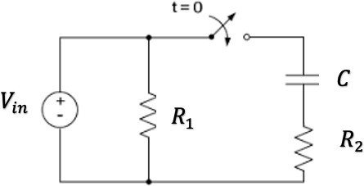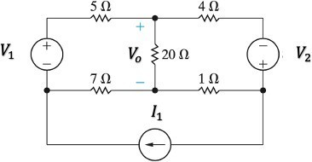To simulate simple passive circuits using DC and Transient analysis.
Page2
- To be able to generate LTspice results using plots for various circuit variables.

Pre-lab Work
Before starting this experiment, you need to study the document “Introduction to LTspice IV with Examples”, by Nicholas Lombardo, Linear Technology, 2015.

Circuits

Figure 1: A DC circuit. Figure 2: Transient circuit.

Procedure
Part (1): DC Analysis.
- Connect the circuit in figure 1. Use the voltage and current sources values given by the lab instructor.
- Using simulation, find the DC voltages and currents for all resistors. Record results in table 1.
- Now make source 𝑉₁ as a variable voltage source and use the DC Sweep function to produce the transfer function curve 𝑉_{𝑜} versus 𝑉₁.

Part (2): Transient Analysis.
- Connect the circuit in figure 2. Use the circuit elements values given by the lab instructor. Set
𝑉_{i𝑛} as a periodic rectangular signal with frequency 𝑓 and maximum amplitude 𝑉_{𝑚𝑎𝑥}. The switch is initially closed.
- Simulate the steady-state response of the circuit. Produce the steady-state voltage waveforms (versus time) across the capacitor 𝐶 and the resistor 𝑅₍. Put these curves together with the
𝑉_{i𝑛} curve on the same plot.
- Now, as the switch is opened at 𝑡=0, simulate the circuit using the Transient analysis function and generate the voltage waveform (versus time) across the capacitor 𝐶 and the resistor
𝑅₂.

Page3
Put these curves together with the 𝑉_{i𝑛} curve on the same plot. Also observe the waveform of the current through 𝑅₍. From the curves, find the time constant of the circuit.
- Change the value of 𝑓 and repeat step 3.

Results and Analysis

Part (1): DC Analysis.

Table 1. DC Simulations in Part (1).

𝑉₁ = 10V 𝑉₂ = 5V 𝐼₁ = 3A | Simulation | Calculation | Difference%
Voltage across 1 Ω resistor | 0.81 V | 0.81 V | %0
Current through 1 Ω resistor | 0.81 A | 0.81 A | %0
Voltage across 4 Ω resistor | 8.75 V | 8.57 V | %0.0018
Current through 4 Ω resistor | 2.19 A | 2.19 A | %0
Voltage across 5 Ω resistor | 11.69 V | 11.88 | %0.0019
Current through 5 Ω resistor | 2.33 A | 2.34 A | %0.0001
Voltage across 7 Ω resistor | 4.67 V | 4.64 V | %0.0003
Current through 7 Ω resistor | 0.6625 A | 0.6625 A | %0
Voltage across 20 Ω resistor | 3.02 V | 2.7625 V | %0.003
Current through 20 Ω resistor | 0.1475 A | 0.1475 A | %0

1. Comment on the difference between simulation and theoretical values in table 1.

All voltage and current differences are less than 0.003%. The simulation results are very close to the results I calculated using the node voltage method. It can be said that they are the same. I think we can ignore this error in practical implementation.
Page4

Part (2): Transient Analysis.

Table 2. Transient Simulations in Part (2).

𝑅₁ = 1k Ω 𝑅₂ = 2k Ω 𝐶 = 1µF | Simulation | Calculation | Difference %
Circuit time constant | 2 ms | 0.66 ms | 0.01

- Comment on the difference between simulation and theoretical values in table 2.

The difference is %0.01, which I think is negligible.

- State your observations on the simulated behavior of the given RC circuit, including the effect of changing the input frequency.

Before t₀=0, there is no change in voltage and current in the circuit because the capacitor is empty. After turning on the switch, the voltage curves of C (blue) and R2 (red) are as follows:
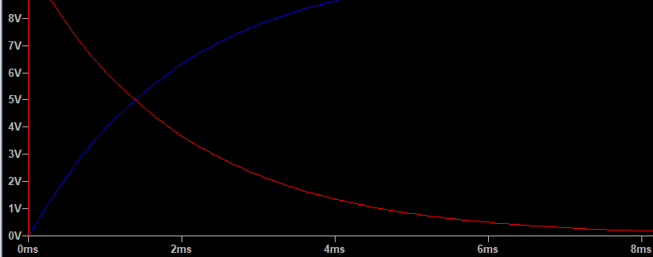

The capacitor charges itself, and the voltage across the resistor connected to the capacitor drops exponentially. The time constant is approximately 2 ms. If I change the frequency and adjust the T_{period} and T_{on} values, I get the same microsecond value. The formula is R*C and we expect the same result.

